For this week’s discussion board, I wanted to further discuss the use of APIs and the relevance they have now and possibly in the future as a more common data source for information on different topics throughout our world. Firstly, API stands for Application Programming Interface which consists of code that governs different access points for the server. The need for APIs can be seen when a client needed to access information from a different application without having to skim over multiple documents of data or if a client wanted information that is most up to date. With having access to an API, it allows different clients the opportunity to obtain data from outside sources. Author Perry Eising provides us with two different instances where APIs are utilized in a situation.

1 – We can send an API a request detailing the information we want

2 – APIs allow sites to alter data on other applications. Example: When you see the share on Facebook or share on Twitter buttons on a video or article on different websites, the site is communicating with the particular account and altering its data by adding the new status or tweet.

In my mind, I imagine an API to be like the vending machines that move within itself to select something to drink, where the API aspect is you entering the code and it will retrieve a certain object or data piece for you. In the picture below, it shows an example of how an API is that access point between the internet and a particular web server. (Eising, 2017)

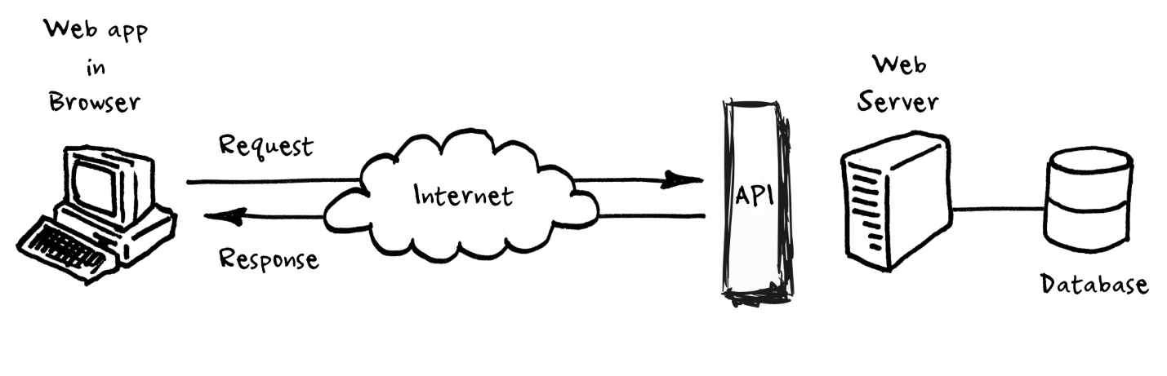

Process of Calling on an API

As you continue to look into the uses and importance of APIs, one example that caught my attention many times was how often we use other logins from sites such as Facebook and Google to login into different applications. Because of this process, the ability to save time has gone up immensely. However, it brings up the issue of security since now another site you are using has the same credentials as the account you are using to sign in. If someone were able to obtain said credentials, they would be able to access all those other applications.

With APIs, I see they’re importance growing because of how many different ones currently exist and how they have integrated into our online world we would not want to go backwards after this. With being able to connect to different applications using this “bridge”, it has allowed us to be more connected and share information at rates that are higher than ever before rather it be in a business or social media environment. Looking towards the future, we must also be aware that access to these APIs is not forever. For example, Twitter had limited its third-party applications’ use of its APIs to decrease alternative Twitter clients. (Proffitt, 2019)

References

Eising, Perry. “What Exactly IS an API?” Medium, Medium, 7 Dec. 2017, [medium.com/@perrysetgo/what-exactly-is-an-api-69f36968a41f](mailto:medium.com/@perrysetgo/what-exactly-is-an-api-69f36968a41f).

Proffitt, Brian. “What APIs Are And Why They're Important.” ReadWrite, 25 Sept. 2018, readwrite.com/2013/09/19/api-defined/